# Tim Daiber – 3rd Year Project – Specs

Tim Daiber

0877880921

G00260494

67 Gleann Rua,

Galway,

Co. Galway

**Table of Contents**

Tim Daiber – 3rd Year Project – Specs 1

**What It is** 1

**Technologies** 2

**Implementation** 2

To do List 7

Progress 7

Expected Learning outcomes 7

Reference 8

Summary 8

Appendix 8

## **What It is**

My Project will an app that will give information / calculate the live expectancy

Of a person.

The user will provide information about themselves (e.g. smoker, weight etc.)

This information will be stored on the database and kept (Datamining).

The information will be calculated by an equation and the user will get an estimated year they will live to.

## **Technologies**

* Android Studio
* Java
* GitHub
* SQLite
* Mozilla FireFox
* SQLiteManager (FireFox add on)

## **Implementation**

#### **Android Studio**

Android Studio is a very good IDE to develop for an Android platform.

Upon Creation of a new Project the main_activity (Main Page) is the page that will be initially loaded upon start up of the app.

In this activity I have decided to Place all the main content of the app.

The user enters all the properties via Checkboxes Spinners etc.

Most information is Displayed through Text Fields.

The main Page can be manipulated in 2 ways:

##### **Palette**

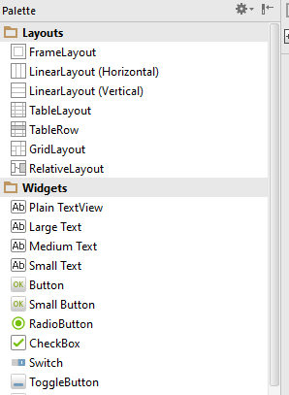The Palette is a good and handy way to add functionality to an Activity.

It is just a drag and drop principle.

Dragging a button onto the activity will automatically create the button in the XML file for the activity.

##### **XML**

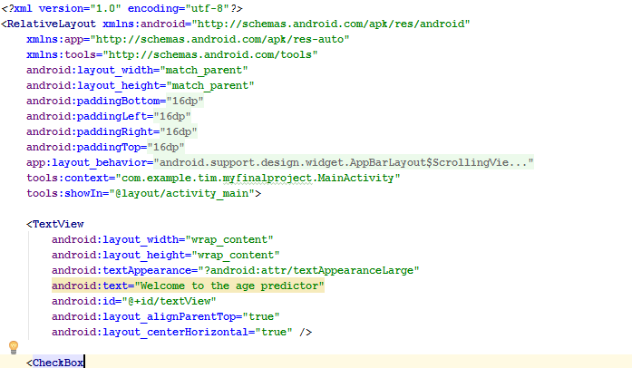The other way to Design the activity can be done through the XML directly.

Of course both of these option can be used together as well.

##### **Design Choices**

In the app that I have created I have decided to make the app as user friendly as possible.

The user input is done in majority through spinner and checkboxes.

This has multiple reason:

1. The

##### **Spinner**

A Spinner is basically a dropdown list in Android Studio.

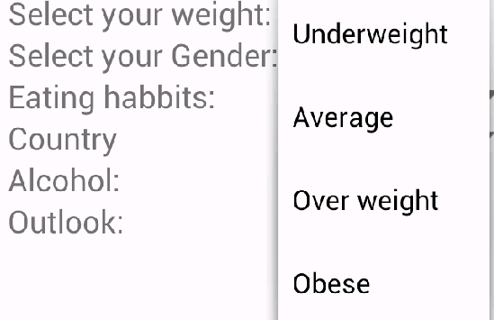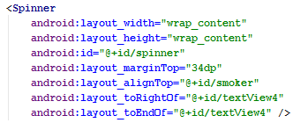To Create a Spinner you could drag it into the activity or by adding it through the XML directly

To add values to the Spinner the string.xml class has to be edited.

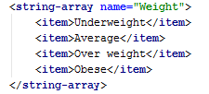This is achieved by creating an Array of Strings

Where each item in the array represents one value that will be displayed in the dropdown list.

To display the items in the string array the activity must be edited through some Java code.

The spinner and the array must be linked together on creation of the app for the items to appear in the spinner.

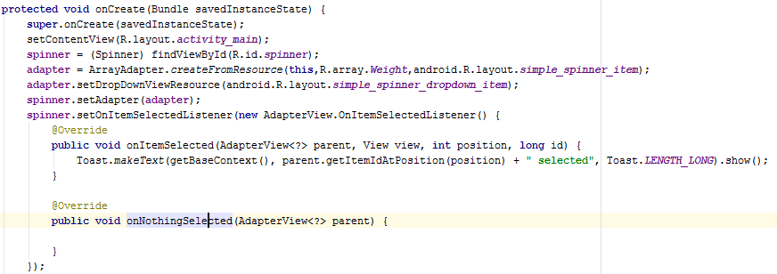

The code snipped above shows the linking of the String array “weight” to the spinner (spinner)

It also gives the functionality of selecting an item.

##### **Check Boxes**

Checkboxes are another easy user friendly way to get information of the user.

Checkboxes can easily be accessed by searching for their assigned id and a simple if statement

Can be used to check if the checkbox is checked or not.

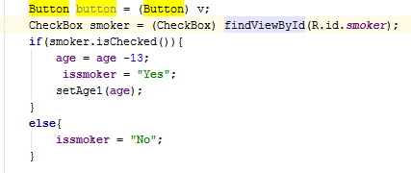

##### **TextFields**

Textfields are an easy way to display messages to the user.

I have used quiet a few text fields to display text to the user.

Also a textField is used to display the calculated age to the user.

###### Toast

Toast is a class that can be used to display popup messages to the user.

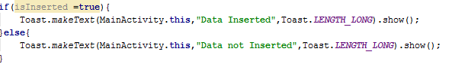

In this toast message the user gets a little popup message to determine if the insertion into the SQLite database was successful.

##### Intent’s

“An Android **Intent** is an abstract description of an operation to be performed. It can be used with **startActivity** to launch an Activity, **broadcastIntent** to send it to any interested BroadcastReceiver components, and **startService(Intent)**or **bindService(Intent, ServiceConnection, int)**to communicate with a background Service.” See Reference 1.

I have used Intents to

#### **Development Ideas**

The Development of the app will be done on Android Studio (Java).

Android Studio will be linked with my GitHub account to store my project and make it easily accessible from anywhere.

The Database will be designed in MySQL workbench and will hold data that the user will input / receive.

I am currently not sure about the server and how it will be implemented or even in what language it will be in. Or even if it will be a part of the project.

#### **Why?**

I have chosen Android Studio to be my IDE since it is an ideal platform to develop android apps.

Java is the language I have chosen since it is native to the android environment.

Photoshop will be used for some design aspects of the app.

## **To do List**

## **Progress**

## **Expected Learning outcomes**

Android app expertise

Database creation and management

Creation and maintenance of a server

Designing and Developing an app

## Reference

1: http://www.tutorialspoint.com/android/android_intents_filters.htm

## Summary

## Appendix